**STAAR Reminders:**

**Get a Good Night’s Sleep**

**Eat a Healthy Breakfast**

**Bring a Book to Read**

**Remember your Strategies**

**Bring Confidence that**

**You WILL Pass the STAAR Test!!!**

***Angleton***

***Junior High***



***2014***

**8th Grade Social Studies**

**STAAR Review Book**

Student Name: _____________

Teacher Name: _____________

# European Exploration and Colonization of North America

# Reasons for European Exploration and Colonization

**Religious Freedom (GOD):** Groups in search of religious freedom founded several colonies. Two of these groups were the Pilgrims and the Puritans, both of which settled in the colony of Massachusetts. Religious freedom was also an important factor in the founding of Pennsylvania. William Penn, a Quaker, founded Pennsylvania on the principle of religious toleration, or acceptance of most religions.

**Economic Gain (GOLD):** Some colonies were founded by groups of business people who wanted an opportunity to make money. Virginia, (1607) the first permanent English colony in North America, is the most famous example of an American colony that was formed as a business venture. Tobacco became Virginia’s main source of wealth. South Carolina also was founded for business purposes. Rice farming became South Carolina’s main source of wealth.

**European Rivalries (GLORY):** The most powerful countries of Europe saw colonies as a way to extend their economic and political power. Competition between European countries such as England, France, and Spain sometimes spilled over into the Americas. For example, England captured the Dutch colony of New Netherland in 1664 and renamed it New York.

***Mercantilism:*** the economic system used by European nations with their colonies

using raw materials to produce finished goods to increase their gold supply.

**3 Colonial Regions Develop**

**1. New England Colonies:** *Massachusetts, New Hampshire, Rhode Island, Connecticut*

* People: Mostly Puritans from England
* Climate: Long cold winters, rocky soil, vast forests
* Economy: Shipbuilding, timber, fishing, whaling, merchant trade

**2. Middle Colonies:** *Pennsylvania, New York, New Jersey, Delaware*

* People: Diverse population from different European countries, Quakers
* Climate: milder winters, longer growing season, good soil for cash crops
* Economy: Cash crops of wheat, other grains, fruits, vegetables, artisans

**3. Southern Colonies:** *Maryland, Virginia, North Carolina, South Carolina, Georgia*

* People: English Anglicans, Catholics, enslaved Africans
* Climate: Warm, rainy, year-round growing season, rich soil for cash crops
* Economy: dominated by plantations, cash crops of tobacco, rice, indigo, and cotton

|  |  |
| --- | --- |
| Technological Innovation | Description |
| **Cotton Gin** | The cotton gin removed seeds from cotton, a task that had previously been done by hand. **Eli Whitney** invented the cotton gin in the 1790s. |
| **Textile factories** | Textile factories produced cloth. **Samuel Slater** established the first textile factory in the U.S. in 1793. He was followed by **Francis Cabott Lowell** and his Lowell Mills. |
| **Interchangeable parts** | Interchangeable parts were parts that could be substituted for one another in the manufacturing process. This reduced the amount of time it took to produce goods. **Eli Whitney** developed interchangeable parts in the early 1800s. |
| **Steamboats** | Steamboats, which were powered by steam engines, increased the speed of river travel. **Robert Fulton** developed the first practical steamboat in 1807. |
| **Steel plow and the McCormick Reaper** | The steel plow, invented by **John Deere**, and the McCormick Reaper, invented by **Cyrus McCormick**, made farming corn and wheat easier and more profitable and contributed to the westward expansion of farming. |
| **Telegraph** | The telegraph, an early form of electronic communication, allowed people to communicate rapidly across long distances. **Samuel Morse** built the first U.S. telegraph system in the 1840s. |

###### Industrialization

The use of machines to produce goods, or industrialization, radically changed life for many Americans.

**Industrialization**:

1. Led to rapid economic growth in the United States
2. Became the main system for manufacturing goods
3. Allowed workers without much skill or experience earn wages
4. **Urbanization**—people moved to cities where most of the factories were located, causing rapid growth of cities.
5. Increased immigration from other countries

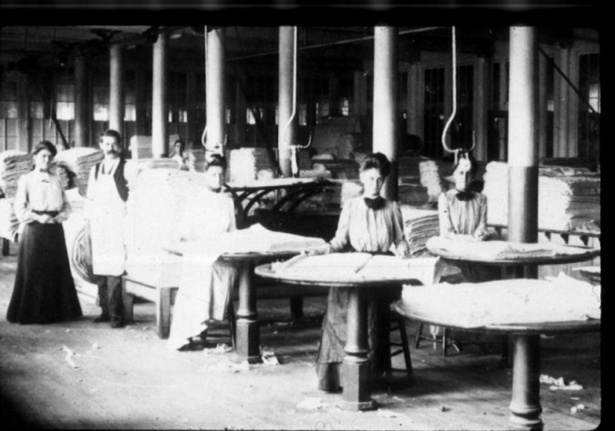

## *Important Dates:*

***1607:*** Jamestown, Virginia- the first permanent and successful English settlement in North America

***1620:*** Mayflower Compact, written by Pilgrims aboard the ship Mayflower, established their own self-government and laws

***1776:*** (July 4) the Declaration of Independence is approved.

***1787:*** the U.S. Constitution is written at the Constitutional Convention in Philadelphia.

***1803:*** Louisiana Purchase- Jefferson buys the Louisiana Territory from France, doubling the size of the United States.

***1861-1865:*** the U.S Civil War- Union (North) vs. Confederates (South)

### *Important Documents and Policies*

### The Magna Carta, signed in 1215 by King John of England, was the first document that limited power of the ruler and established the principles of trial by jury and one could not be deprived of life, liberty and property.

* **The** **Mayflower Compact** was the document written aboard the *Mayflower* in 1620 by the founders of the Plymouth colony, the Pilgrims. This document represented an early form of colonial self-government and an early form of a written constitution, establishing the powers and duties of the government.
* **The** **Fundamental Orders of Connecticut,** drafted by the settlers in the Connecticut River colony in 1639,was the first written constitution in the colonies establishing a democratic government controlled by citizens.
* **The Virginia House of Burgesses**, established in **1619**, was thefirst representative assembly (group) in the American colonies. Famous delegates included Patrick Henry, Thomas Jefferson, and George Washington. **The Revolutionary Era**

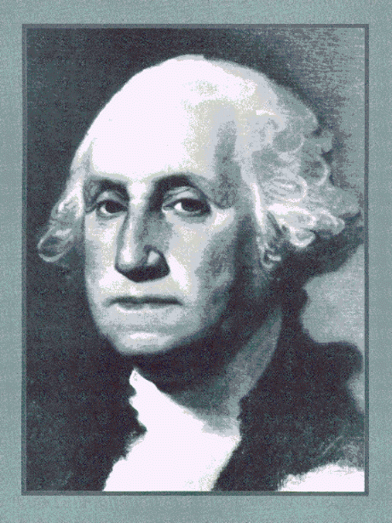

***George Washington*** - Commander of the Continental Army during the American Revolution.  He was also the 1st President of the United States.

***Thomas Jefferson*** – Thomas Jefferson was the primary author of the Declaration of Independence and the third President of the United States. He was inspired by English philosopher John Locke’s ideas of citizens having power over their governments.

***1776: Declaration of Independence*** - Lists grievances against

King George III and announces to the world that the colonies are forming their

own nation and breaking away from England.

***Unalienable rights*** - rights that cannot be taken away: life, liberty and the pursuit of happiness.

**Reasons for Colonists’ Discontent (anger)**

* Imposing taxes on colonists without their approval (*No taxation without representation!)*
* Forcing colonists to quarter (house) British troops
* Denying colonists the right to trial by jury in many cases
* Preventing colonists from trading with nations other than Great Britain
* Denying colonists legislative representation in Parliament

**Causes of Revolution:**

* The British taxed the colonies for revenue to pay for the French and Indian War.
* **"No taxation without Representation!"** - Colonists resented being taxed without having a voice in Parliament.
* Tax acts passed include the **Stamp Act** (tax on most printed paper in the colonies**), Sugar Act** (placed taxes on sugar on other luxuries), and **Tea Act** (tax on tea)
* **The Boston Massacre** – conflict between colonists in Boston and British soldiers which resulted in the death of five people; named a “massacre” by Samuel Adams, and used as propaganda against the British.
* **The Intolerable Acts** – A series of laws passed by Parliament to punish the people of Boston and Massachusetts and bring the colonists under control

***Loyalists*** - Americans who supported Great Britain during the revolution.

***Patriots*** - Americans who favored independence from Great Britain during the revolution.

## Events that led to the Civil War:

Sectionalism, Wilmot Proviso, Compromise of 1850,

Fugitive Slave Act, *Uncle Tom’s Cabin*, Bleeding Kansas70

John Brown, Election of Lincoln in 1860

## Important Battles:

1. **Fort Sumter**: first battle of the Civil War
2. **Battle of Gettysbu**rg: turning point of the war, ends Lee’s attempt at winning in northern territory.
3. **Siege of Vicksburg**: victory by Grant gives the Union complete control of the Mississippi River.

## Results of the Civil War

* Robert E. Lee surrenders at **Appomattox Courthouse** in 1865 and the South loses the war.
* Lincoln is assassinated by John Wilkes Booth five days after the end of war.
* The Southern economy is devastated while the Northern economy became stronger than before the war.
* Reconstruction begins.

***Reconstruction (1865-1877)***– The period after the Civil War in the US when the southern states were reorganized and reintegrated into the Union.

***Freedmen’s Bureau:*** federal agency that supplied the newly freed slaves with money, education, houses, and protection.

***“Carpetbaggers”***: Northerners that went south to help former slaves.

***“Scalawags”***: Southerners that supported helping the former slaves.

### Reconstruction Amendments

**13th Amendment** – Abolished slavery in all of the United States.

**14th Amendment** – Gave citizenship and equal protection to anyone born in the U.S.

**15th Amendment** – Gave black men the right to vote.

***The Civil War (1861-1865)*** – War between the North and South

***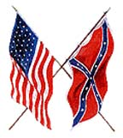*Causes of the Civil War**

* Differences between the North and South over slavery

and the issue of states right’s.

* Increase of anti-slavery sentiment in the North

**The Plantation Economy** – After the invention of the cotton gin by Eli Whitney in 1793, the plantation system grew, especially in the South. The cotton gin made it easier and cheaper to remove the seeds from cotton and cotton became a much more profitable crop. This increased the demand for slaves in the South.

**The firing on Fort Sumter** – Begins the Civil War; first battle of the Civil War, which took place on April 12, 1861.

**Abraham Lincoln** *-* President of the US during the Civil War. Lincoln was the first Republican President and his election encouraged the South to **secede** (withdraw) from the Union and form the **Confederate States of America**.

***“Copperheads”:*** Northern Democrats that were against the Civil War and went against Lincoln’s policies.

Ulysses S. Grant – Supreme Union general during the Civil War and later served as President of the United States.

Robert E. Lee – Supreme Confederate general during the Civil War.

##### Jefferson Davis – President of the Confederate States of America.

**Emancipation Proclamation (1863)** – Document by Lincoln, declaring that all of the slaves in the South were free in territories under rebellion.

**Gettysburg Address** – *“Four Score and seven years ago…”* Speech given by Lincoln after the Battle of Gettysburg. In the speech, Lincoln stated, "We here highly resolve that these dead shall not have died in vain--that this nation, under God, shall have a new birth of freedom--and that government of the people, by the people, for the people, shall not perish from the earth."

# Other Significant Revolutionary Individuals

*King George III* – King of Great Britain during the American Revolution who disbanded the colonial legislatures, taxed the colonies, and refused the Olive Branch Petition leading to the final break with the colonies.

# *Samuel Adams* – was a founder of the Sons of Liberty who started the Committees of Correspondence to stir public support for American independence, organized the Boston Tea Party.

***Paul Revere-*** member of Sons of Liberty, Boston silversmith, created Boston Massacre engraving, rode to Lexington and Concord warning of the arrival of the British.

***Benjamin Franklin*** – was an inventor, statesman, diplomat, and signer of the Declaration of Independence. He negotiated the alliance with France and then the Treaty of Paris which ended the war. He also participated in the U.S. Constitutional Convention in 1787.

***The Marquis de Lafayette*** – was a wealthy French citizen who came to America to support the Revolution. He became good friends with General Washington and was with him at Valley Forge.

*Thomas Paine* – wrote pamphlets like *Common Sense* and *The Crisis* to encourage American independence and resolve.

Important Revolutionary Events:

The first shots of the American Revolution were fired at Lexington, Massachusetts, in April 1775.

Concord, Massachusetts, was the site of the first battle of the American Revolution.

The Battle of Saratoga in New York was the turning point of the American Revolution; it resulted in a major American victory that helped to convince the French government to join the Americans against the British.

The British, commanded by Lord Charles Cornwallis, are defeated at Yorktown, Virginia by George Washington’s troops, signaling the end of the American Revolution.

The **Treaty of Paris of 1783** ended the American Revolution and forced Britain to recognize the United States as an independent nation.

# 1787: The United States Constitution

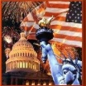***Influences:***

**Magna Carta** (see page 2

**English Bill of Rights** **(1689)** – Influenced the Constitution by limiting the King’s powers and forbidding cruel and unusual punishment; granting the right to bear arms; the legislative branch must pass laws; taxes must be approved by the legislative branch.

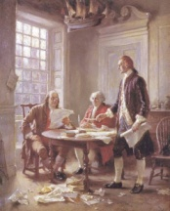

***Important Documents***

**Declaration of Independence (1776)** – The Bill of Rights and the Constitution addressed grievances from the Declaration of Independence. It also lists the unalienable rights: life, liberty and the pursuit of happiness.

**Federalist Papers (1787-1788)** – Essays written to encourage ratification of the constitution. The authors include Alexander Hamilton, John Jay, and James Madison.

***The Articles of Confederation (1781****)* – First form of government established by the 13 states. Replaced by the US Constitution because it created a weak form of central government.

## Weaknesses included…

* No executive branch to enforce laws
* Congress could not collect taxes or regulate trade
* No national court system
* Each state had only one vote in Congress, regardless of population

## *Important Facts*

**1787** – Delegates from the 13 states drafted the US Constitution in Philadelphia.

**The Preamble** – is the introduction of the Constitution that states its purpose. ***We the People, in order to form a more perfect union…***

**Great Compromise –** Compromise between the big and small states over representation in Congress. Created a bicameral (two-house) Congress – the Senate and the House of Representatives. The number of members in the Senate is equal for all states (2), and the number of representatives in the House is proportional (dependent on the size) to a state’s population.

**Three-Fifths Compromise –** Compromise between northern and southern states over how slaves would be counted in determining a state’s population. Three out of every five slaves would be counted.

**Ratification** – to formally approve. ***Before it could go into effect, 9 out of the 13 states had to ratify the Constitution.***

###### Sectionalism and the Civil War



##### The Growth of Sectionalism – Sectionalism, or conflict, between the North and the South increased during the 1800s.

Two main causes of sectionalism were:

* Disagreements over states’ rights
* The issue of slavery in the western territories

Northerners felt that the federal (national) government had broad powers under the Constitution.

Southerners felt that the federal government’s power under the Constitution was limited.

*The Nullification Crisis*: Andrew Jackson vs. John Calhoun

In 1832, the U.S. Congress placed a tariff on manufactured goods. This benefited U.S. manufacturers in the northeast but increased prices for consumers in other parts of the country. Southerners, led by **John C. Calhoun** felt that the tariff was unfair because there was very little manufacturing in the South and called it the “**Tariff of Abominations**”. South Carolina nullified or voided the tariff saying that it would secede from, or leave, the Union. **President Andrew Jackson** threatened to send troops to South Carolina to enforce the tariff. Compromise was reached with the help of **Henry Clay** – Congress reduced the tariff and South Carolina backed down.

##### The Reform Movements

People began to work to solve social problems. **Abolitionists**, such as **Fredrick Douglass**, **Sojourner Truth, William L. Garrison, and Harriet Tubman,** worked to end slavery in the U.S. The **temperance movement** urged people to stop drinking alcohol. The **women’s rights movement**, led by **Elizabeth Cady Stanton** and **Susan B. Anthony**, worked for and supported the expansion of rights for women including the right to own property and to vote. The **public education movement,** led by **Horace Mann**, pressed for government-supported education for all children. **Dorathea Dix** worked to improve prisons. Author **Harriet Beecher Stowe** drew attention to the horrors of slavery. Stowe’s novel, ***Uncle Tom’s Cabin***, caused many Americans to call for an end to slavery. Famous speeches include **Elizabeth Cady Stanton’s *Declaration of Sentiments*** and**Sojourner Truth’s *Ain’t I a Woman?***  The **Civil Disobedience** movement was led by the author Henry David Thoreau’s refusal to pay taxes to support the US-Mexican War.

###### Consequences of Westward Expansion

##### http://www.tooter4kids.com/Thanksgiving/_derived/trail_of_tears.htm_txt_trailoftears.gif

##### Indian Removal – In 1830, President Andrew Jackson had the Indian Removal Act passed. The act called for Native Americans living in the southeastern United States to be moved west of the Mississippi River. The most well known incident of removal is known as the Trail of Tears, which was the forced removal of the Cherokee Indians in 1838 and 1839. Thousands of them died during the forced march.

**The Annexation of Texas –** In 1845, Texas becomes the 28th state in the U.S., Mexico claims Texas still belongs to them.

**The Mexican War** – The Mexican War began in 1846 and was caused by the annexation of Texas. The war ended in 1848 with the signing of the **Treaty of Guadalupe Hidalgo**. The United States was granted a large portion of northern Mexico, which was known as the **Mexican Cession**. This region makes up most of the western part of the United States.

# The United States Constitution (1787)

**Separation of Powers** – Divides the powers of government into 3 branches.

1. 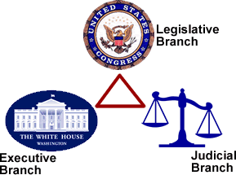**Legislative Branch** – makes the laws
2. **Executive Branch** – executes the laws
3. **Judicial Branch** – interprets the laws

**Checks and Balances** – makes sure no branch of the government becomes too powerful. Example: The President can veto a bill, Congress can impeach a president, the Supreme Court can rule a law unconstitutional.

**Federalism** – Power is shared between the states and national government.

**Limited government** – the power of the government is restricted by the U.S. Constitution. “No one is above the law.”

**Republicanism** – A system where people vote for elected representatives to run the government.

**Popular Sovereignty** – The people hold the ultimate power. “We the people…”

**Federalists:** wanted the Constitution ratified as is, wrote the ***Federalist Papers***

**Anti-Federalists:** opposed ratification without a Bill of Rights added.

## *Bill of Rights*

* 1st ten amendments to the Constitution
* Protect individual rights and liberties

**1st Amendment** – Freedom of speech, religion and press; right to assemble; right to petition

**2nd Amendment** – Right to bear arms.

**3rd Amendment** – No quartering of troops during peace time.

**4th Amendment** – No unlawful search and seizure.

**5th Amendment** – Right to Due Process, no double jeopardy, do not have to testify against yourself.

**6th Amendment** – The right to a fast and public trial, right to have a lawyer.

**7th Amendment** – Trial by jury in civil cases.

**8th Amendment** – No cruel or unusual punishment.

**9th Amendment** – Rights reserved to the people.

**10th Amendment** – Powers reserved to the states

#### The New Nation

##### The Northwest Ordinance (1787) – created a process for U.S. territories to become states.

**Washington’s Farewell Address** – President Washington served two terms as president of the United States. In his last speech Washington made these key points:

• Warned against alliances with other countries

• Warned against political parties

**The Marshall Court** - John Marshall served as chief justice of the U. S. Supreme Court. During his tenure he shaped federal law and increased the power of the federal government. Most important was the ***Marbury v. Madison*** decision (1803) in which he ruled that the federal courts had the power to determine whether or not a law was constitutional. This power became known as **Judicial Review.**  Marshall’s other important cases were *McCulloch vs. Maryland* and *Gibbons vs. Ogden.*

The ***XYZ Affair***and ***Alien and Sedition Acts****:* Events during the John Adams Presidency which caused friction with France and with many people in the U.S. Jefferson and Madison write the *Virginia and Kentucky Resolutions* to oppose Adams, introduce idea of State’s Rights.

***1803:*** the **Louisiana Purchase** – Thomas Jefferson buys territory from France that doubles the size of the U.S.

1804-1806: ***Lewis and Clark*** explore the Louisiana Territory. With the help of a native woman named **Sacagawea**, they bring back much valuable information.

**The War of 1812** – Great Britain had been seizing American ships, kidnapping American sailors, and helping Natives against the U.S. government. This led to the outbreak of war between the United States and Great Britain. The war ended in 1815 without an obvious winner.

**KEY EVENTS** **of the War of 1812**: **Francis Scott Key** wrote “The Star Spangled Banner”, **Andrew Jackson** wins the battle of New Orleans, a new spirit of unity, patriotism, and nationalism spreads throughout the U.S., leads to the **Era of Good Feelings**.

**The Monroe Doctrine** (1823) President James Monroe issued this doctrine declaring the Western Hemisphere off-limits to further colonization by European powers.

#### Westward Expansion

**Factors That Encouraged Westward Expansion:**

1. **Economic Growth** – the Industrial Revolution, the spread of cotton and wheat farming, advances in transportation, and the **California Gold Rush** (1849) all contributed to westward expansion.
2. **Territorial Expansion** – Treaty of Paris 1783, the Louisiana Purchase (1803), Annexation of Texas (1845), the Oregon Territory (1846), the Mexican Cession (1848), and the Gadsden Purchase (1853).
3. **The Mormon Migration** – Mormons, seeking religious freedom, head west and settle in modern-day Salt Lake City, Utah.

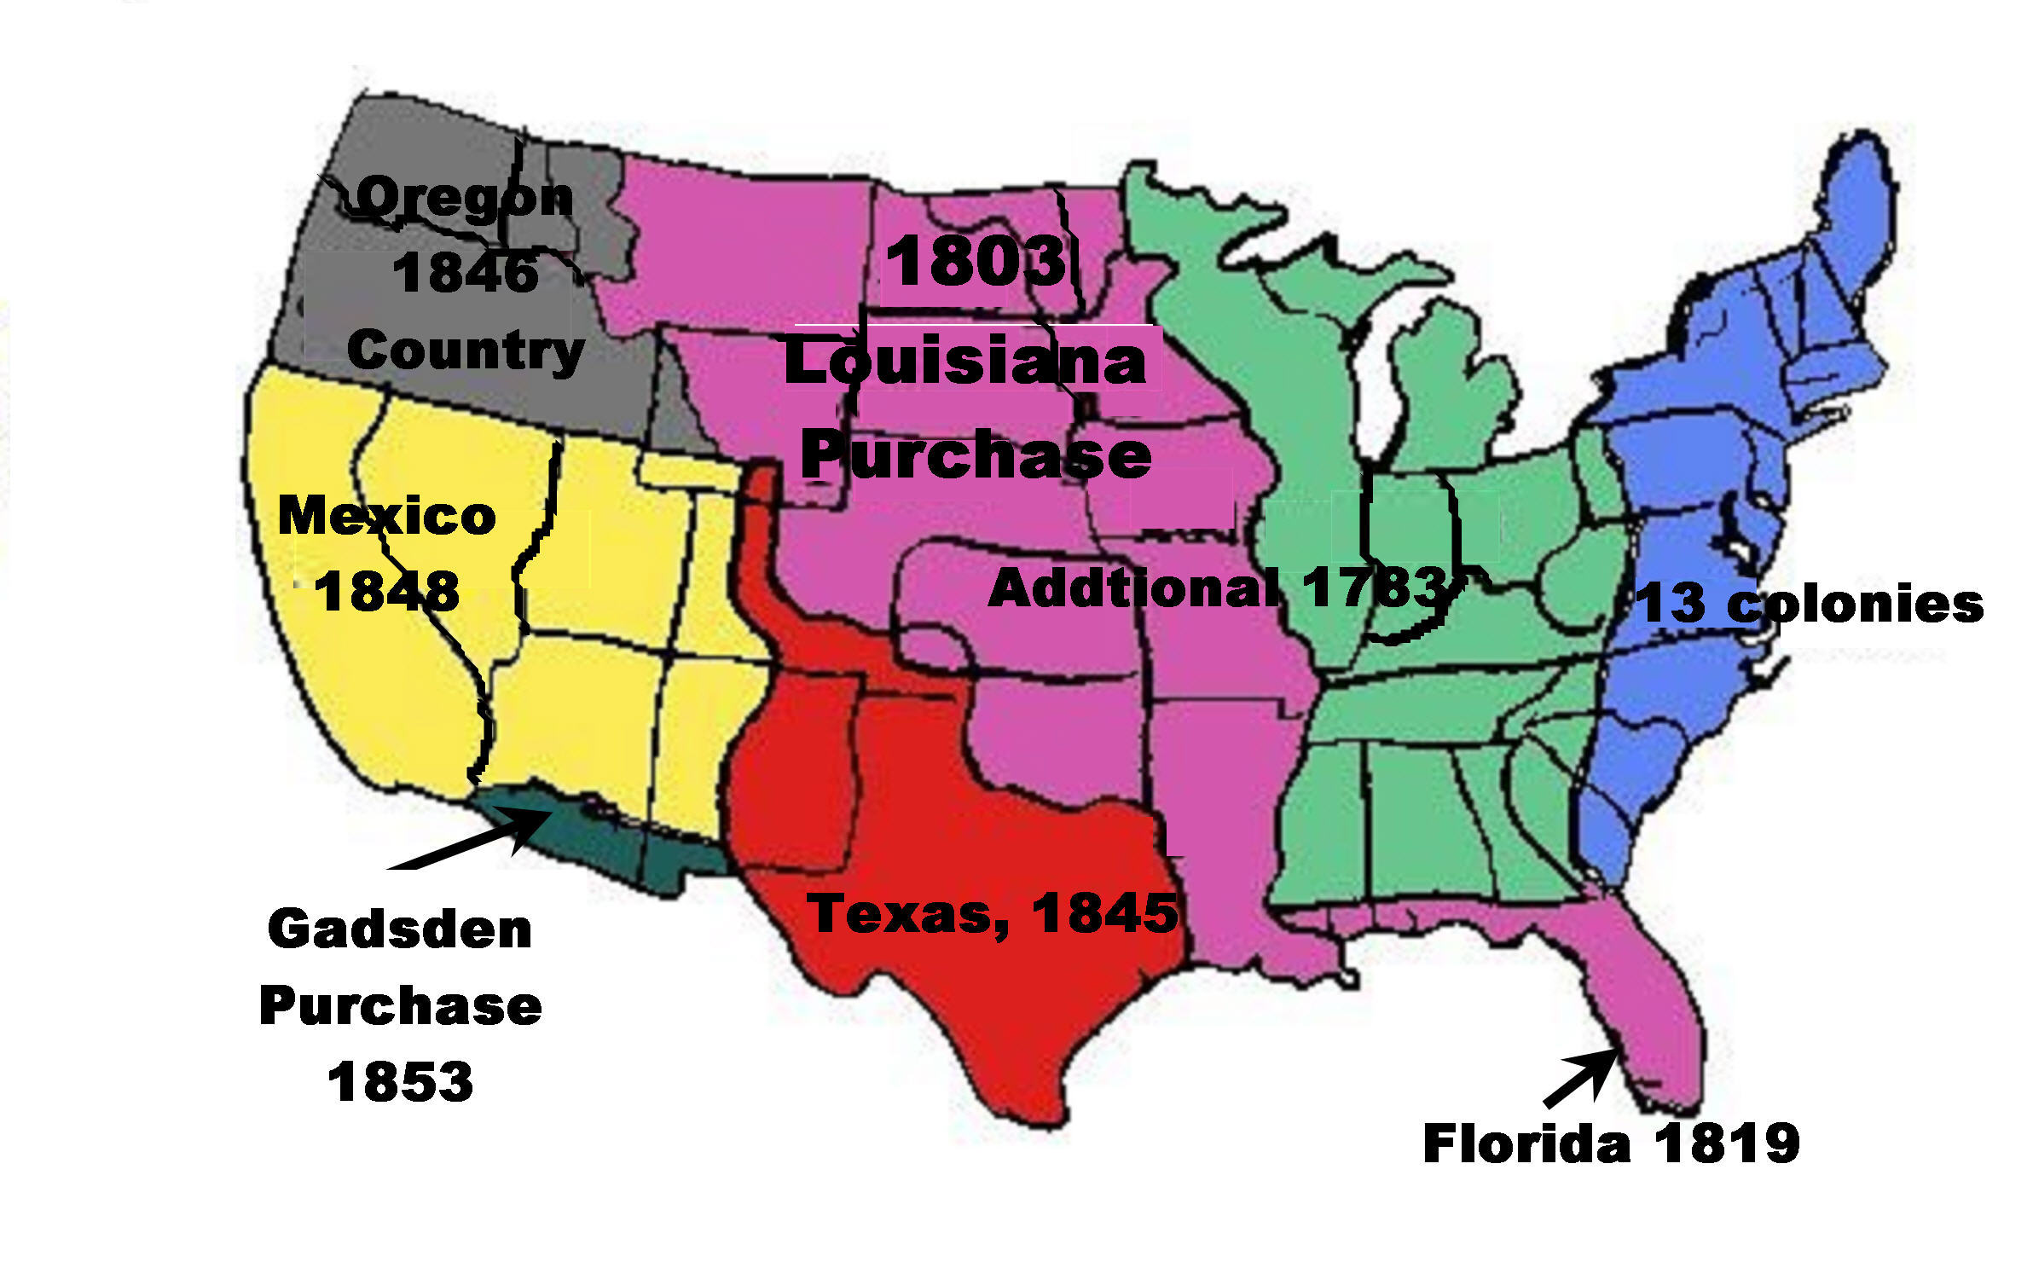

1. **Manifest Destiny** – The belief that America had the God-given right to expand across the continent.

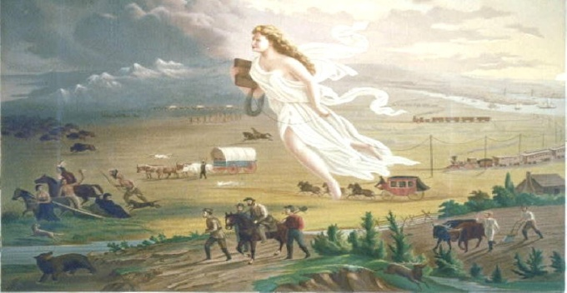

***Even more important historical figures/events:***

**Thomas Hooker:** Puritan leader, founder of Connecticut, main writer of the Fundamental Orders of Connecticut.

**Charles de Montesquieu:** French philosopher whose ideas of separation of powers and checks and balances inspired Jefferson and Madison.

**Wentworth Cheswell:** African-American patriot during the American Revolution, made a midnight run to New Hampshire to warn of a British invasion, fought with Continental Army at Saratoga.

**Abigail Adams:** American patriot, wife of John Adams, and early supporter of women’s rights.

**Mercy Otis Warren:** American patriot woman, famous for writing anti-British Revolutionary poetry and books.

**James Armistead:** former slave, served in the Continental Army under Marquis de Lafayette, was also a spy for the Americans.

**Bernardo de Galvez:** Spanish naval commander, helped the Continental Army, defeated a British fleet at New Orleans, secured the Gulf of Mex.

**Crispus Attucks:** African-American patriot, shot and killed at the Boston Massacre, 1st American to be killed by the British.

**Haym Salomon:** polish-born Jewish immigrant, banker and financier, supplied the U.S. government with loans to finance the Revolutionary War.

**William Carney:** African-American soldier that fought with the 54th Massachusetts Regiment in the Civil War, first black soldier to win the Medal of Honor.

**Philip Bazaar:** Chilean immigrant, Hispanic Union naval hero during the Civil War, received the Medal of Honor.

**Battle of Antietam**: bloodiest one-day battle of the Civil War, 28,000 dead, close victory for the North, ended Lee’s attempt at winning in Maryland..

**Lincoln’s First Inaugural Address:** “One section of our country believes slavery is right and ought to be extended, while the other believes it is wrong and ought not to be extended. This is the only substantial dispute. Physically speaking, we cannot separate. We cannot remove our respective sections from each other nor build an impassable wall between them. A husband and wife may be divorced and go out of the presence and beyond the reach of each other, but the different parts of our country cannot do this…In your hands, my dissatisfied fellow country-men, and not in mine, is the momentous issue of civil war.

**Lincoln’s Second Inaugural Address:** ““With malice toward none, with charity for all, with firmness in the right as God gives us to see the right, let us strive on to finish the work we are in, to bind up the nation'wounds, to care for him who shall have borne the battle and for his widow and his orphan, to do all which may achieve and cherish a just and lasting peace among ourselves and with all nations.”

**Jefferson Davis’s Inaugural Address:** (excerpt)”Our present position has been achieved in a manner unprecedented in the history of nations. It illustrates the American idea that government rests upon the consent of the governed, and that it is the right of the people to alter or abolish a government whenever it becomes destructive of the ends for which it was established. The declared purposes of the compact of Union from which we have withdrawn were to establish justice, insure domestic tranquillity, to provide for the common defence, to promote the general welfare, and to secure the blessings of liberty for ourselves and our posterity; and when in the judgment of the sovereign States now comprising this Confederacy it had been perverted from the purposes for which it was ordained, and had ceased to answer the ends for which it was established, an appeal to the ballot box declared that so far as they were concerned the government created by that compact should cease to exist..”

**Hiram Rhodes Revels:** First African-American to be elected into the U.S. Senate, represented Mississippi.

**Homestead Act:** 1862 law that gave loyal Americans 160 acres of land west of the Mississippi River as long as they lived on it for 5 years.

**Dawes Act:** 1887 law which allowed individual Native Americans the right to own their own land in reservations and established a path to citizenship for Natives.

**Morrill Act:** 1862 law that provided federal lands and money for the establishment of higher-education facilities throughout the United States greatly increased access to colleges and universities for millions of Americans.

**Draw Your History Dates/Eras**

**Hand Strategy**

**Write the 8 Step Approach to Answering Questions.**

**1.______________________________**

**2.______________________________**

**3.______________________________**

**4.______________________________**

**5.______________________________**

**6.______________________________**

**7.______________________________**

**8.______________________________**

**Additional Social Studies Strategies**